Lesson 3.1: Network Modeling

Understand Network Equilibrium Model: Braess’ Paradox

|  |
| --- |
| Braess' paradox, credited to the German mathematician Dietrich Braess, states that adding extra capacity to a network when the moving entities selfishly choose their route, can in some cases reduce overall performance. This is because the Nash equilibrium of such a system is not necessarily optimal.  The paradox is stated as follows:  "For each point of a road network, let there be given the number of cars starting from it, and the destination of the cars. Under these conditions one wishes to estimate the distribution of traffic flow. Whether one street is preferable to another depends not only on the quality of the road, but also on the density of the flow. If every driver takes the path that looks most favorable to him, the resultant running times need not be minimal. Furthermore, it is indicated by an example that an extension of the road network may cause a redistribution of the traffic that results in longer individual running times."  Source: http://en.wikipedia.org/wiki/Braess%27s_paradox |

|  |  |
| --- | --- |
| * | * |

**3.1.1 Learning objectives:**

1. How to create a network by importing an Excel file in NeXTA.
2. Understand modeling principles of user equilibrium
3. Know how to setup BPR function parameters for special link types
4. Understand the impact of adding a link and analyze the performance at link, path and network levels
5. The impact of different levels of demand on Braess’ paradox
6. Understand the impact of road pricing on Braess paradox and how to resolve Braess’ Paradox

**3.1.2 General description of traffic assignment:**

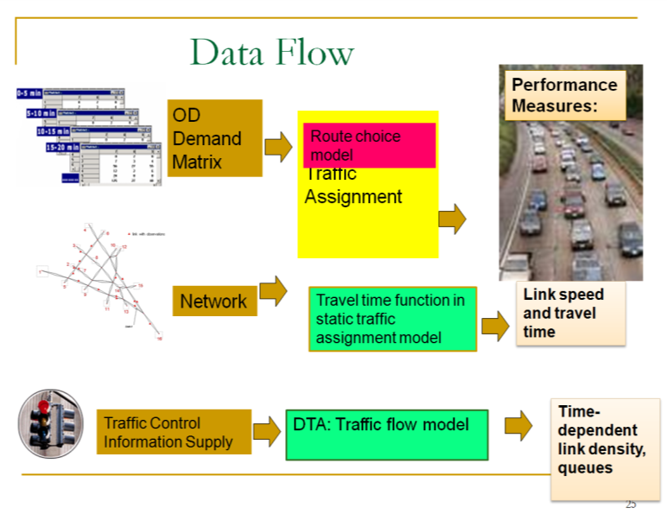

Traffic assignment loads an origin-destination (OD) trip matrix onto links of a traffic network, while satisfying a certain route choice behavioral model, e.g., Wardrop’s first and second principles of network equilibrium (Wardrop, 1952).

Traffic assignment is used to predict/estimate how trip-makers may shift to other routes or departure time in response to a number of strategies such as road pricing, incidents, road capacity improvement and traffic signal re-timing.

For example, tolling typically lead to traffic diversion on alternative routes and/or other transportation modes, and many traffic congestion mitigation strategies should be developed to improve the capacity to which the traffic may be diverted, for example, signal optimization, traveler information provision, and transit operation.

The common time periods of network equilibrium analysis can be morning peak, afternoon peak and off-peak, and we can use the time of day factor to calculate the trip in the peak hour (e.g., morning peak may be 11% of daily traffic) from a 24-hour demand volume.

**Static Traffic Assignment**

There are a number of key components for static traffic assignment methods:

1. OD trip table that describes the flow from each origin zone to each destination zone (per hour)
2. A traffic network consisting of nodes, links and link volume delay functions
3. Route choice principle(s) that describes the spreading of trips over alternative routes due to congested conditions
4. Volume delay function, such as the BPR (Bureau of Public Roads) function that shows increased link travel time as an increase in link volume

TT = FFTT [1 + 0.15(v/c)4]

where:

TT = link travel time

FFTT= free-flow travel time of link

v = link flow

c = link capacity

[Remark: Typically, the travel time function of a link only depends on its own flow, while ignoring link volume on opposing or conflicting directions. The link capacity might not be a strict upper limit on link flow.] 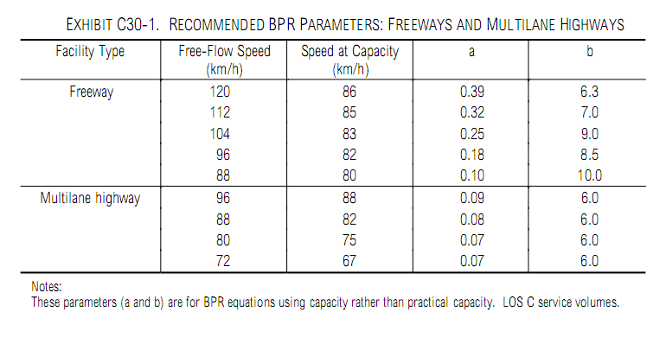

Source: HCM 2000, BPR Parameters for Freeway and Highway

As one of the **simplest** cases of route choice behavior, Wardrop’s first principle, user equilibrium (UE), assumes road users are “selfish (or non-cooperative)” and have complete knowledge about the network. The UE principle requires iterations to reach the following UE conditions:

* No individual trip maker can reduce his path costs by switching routes.
* All used routes between an O-D pair have equal and minimum costs, while all unused routes have greater or equal costs (to the used path costs).

|  |
| --- |
| References:  Wardrop (1952) proposed the user equilibrium and system optimal principles of route choice behavior in his seminal paper, and Beckman et al. (1956) formulated the static user equilibrium traffic assignment problem as an equivalent convex mathematical programming problem. Since their influential contributions, the development of the static network assignment formulations, algorithms and applications have made remarkable progress. The books by Sheffi (1985) and Patriksson (1994) provide the most comprehensive coverage on the static traffic assignment problem and its variants.  Wardrop, J.G. (1952). Some Theoretical Aspects of Road Traffic Research, Proceedings, Institution of Civil Engineers II(1), pp. 325-378.  Beckmann,M. McGuire, C. B. Winsten. C.B, (1956). [Studies in the Economics of Transportation](http://cowles.econ.yale.edu/archive/reprints/specpub-BMW.pdf). Yale University Press: New Haven: <http://cowles.econ.yale.edu/archive/reprints/specpub-BMW.pdf>  Patriksson, M. (1994) The Traffic Assignment Problem: Models and Methods. Koninklijke Wohrmann, Zutphen, The Netherlands. <http://www.math.chalmers.se/~mipat/traffic.html>  Sheffi, Y. (1985). Urban Transportation Networks: Equilibrium Analysis with Mathematical Programming Methods, Prentice-Hall, NJ. <http://web.mit.edu/sheffi/www/urbanTransportation.html> |

# 

# 

# Task 1: Build a network for static traffic assignment, and configure BPR parameters

This task will help you be familiar with basic input for traffic assignment and reproduce the famous Braess paradox.

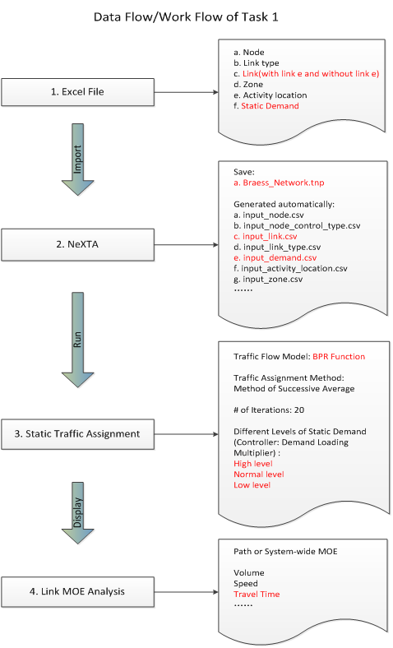

In this task, the user needs to locate NeXTA.exe , “Braess_Network.tnp” file.

**Step 1:** Locate a file called "NeXTA.exe " from the Braess Network Data Set and open the application.

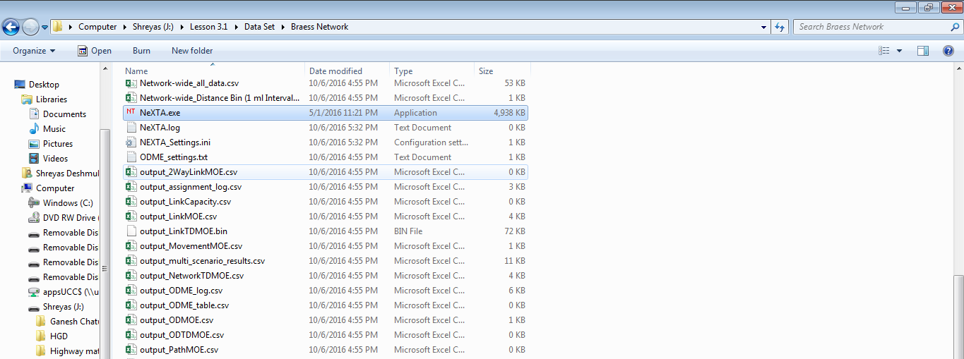

**Step 2:** Now, in NeXTA, click File 🡪 Open Traffic Network Project 🡪 and open the Braess_Network.tnp from the Braess Network Data Set.

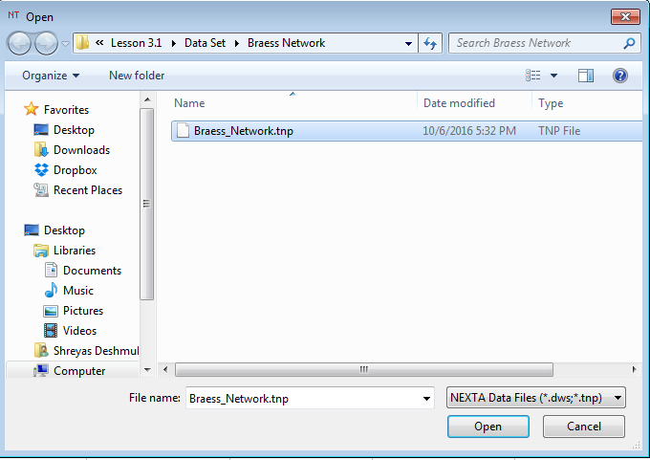

The following network file will be loaded into NeXTA which has 4 nodes and 5 links. Try to increase or decrease the size of nodes by using the “+” and “-” buttons in the GIS layer panel.

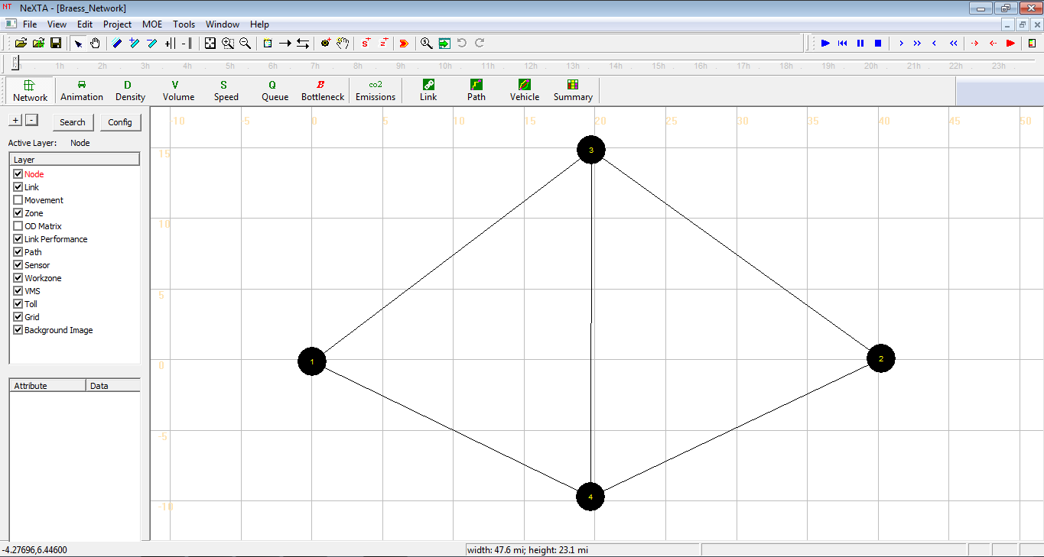

For notational convenience, the following discussion denote link1->3; 4->2; 1->4; 3->2; 3->4 as a, b, c, d, e, respectively.

# Task 2: Run simulation for the Braess network to carry out traffic assignment using the BPR function.

Step 1: Verify the BPR parameters in the below. You can view these parameters in the excel file ‘’Braess_Network.xls” in the Braess Network Data Set. You can also view this data table by making sure the Link layer is active in the GIS layer panel in NeXTA, right-clicking and selecting 'View Link Data Table’.

|  |  |  |  |  |  |  |
| --- | --- | --- | --- | --- | --- | --- |
|  | Travel time function | Link Length | Lane capacity | # of lanes | BPR_alpha | BPR_beta |
| Links a, b | (v/100) | 0.01 | 1714 | 1 | 100 | 1 |
| Links c, d | 45 min | 45 | 1900 | 3 | 0 | 1 |

|  |
| --- |
| Question 1:  How do we specify the and for the links in Braess Network.  TT = FFTT[1 + ]      Answer:  t=T/100 is re-expressed as t=v/100 --> FFTT = 0.01; = 100; c = 100; =1  so that the reconstructed function is 0.01*(1+100v/100) = 0.01+ v/100, which is close to v/100.  t=45 is re-expressed as t=45 --> FFTT = 45; = 0; c = any value; =0  A->B --> FFTT = 0; = any value; c = any value; = any value |

Step 2: Select a traffic flow model and Traffic Assignment Method.

Click the button , then a dialog box named “Review Simulation/Assignment Settings” appears. Choose the option ‘Point Queue Model’ and 20 iterations.

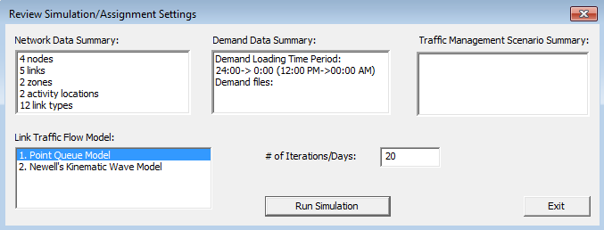

Then click “OK” to start simulation.

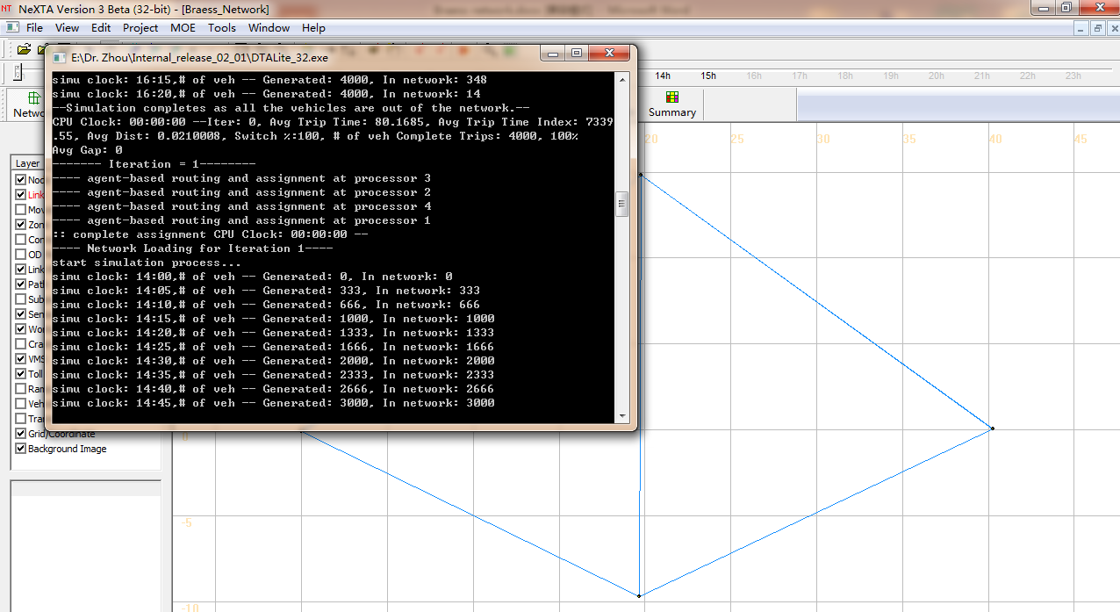

Step 3: Review summary statistics.

When the simulation ends, an information dialog appears, allowing users to view essential simulation statistics.

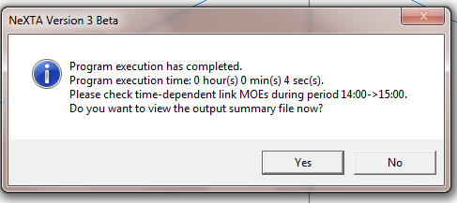

After clicking the option “Yes”, the user can see the output_summary.csv file opened in Excel, which shows detailed information about the simulation results.

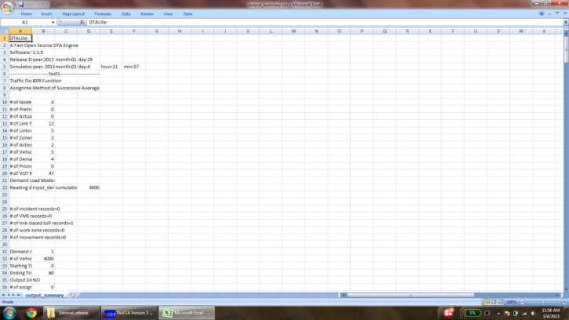

Then close the output_summary.csv file.

Step 4: Display the link volume.

This step is to visualize important link attributes and simulation results on the map. First, click  (the button to the extreme left in NEXTA), which opens up a dialog box titled “Display Configuration”.

Selecting the Link Text Label to be displayed: For example, the users want “Total Link Volume” to be displayed on the map. Under the tab “Link Text Label”, choose “Total Link Volume” from the list and click “OK”.

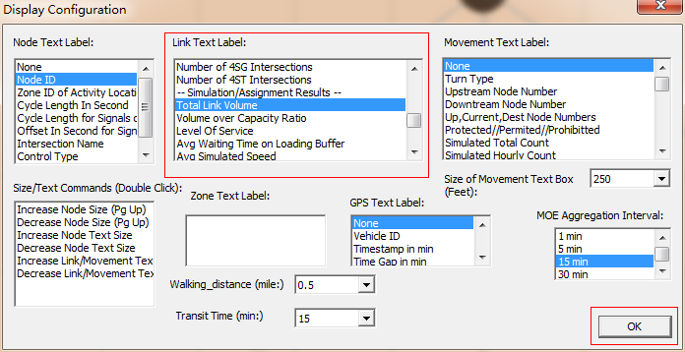

The volume values on each link are shown in the map as shown below.

|  |  |  |  |  |
| --- | --- | --- | --- | --- |
| link | a | b | c | d |
| Total Link Volume (vhc) | 2006 | 1994 | 1994 | 2006 |

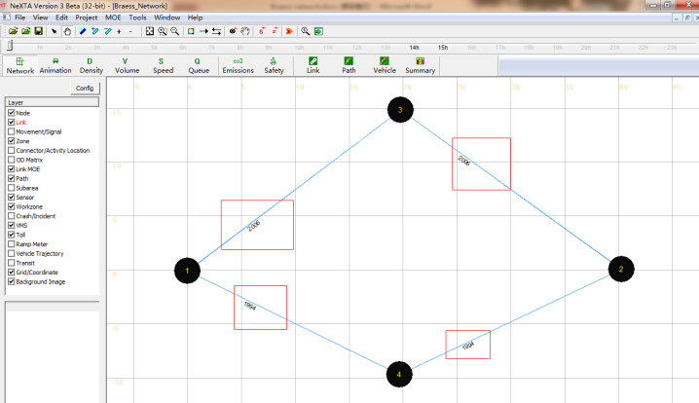

This is a modeless dialog, so users can also change the text label selected. Without closing the “display configuration” dialog box, the user can select different text labels such as Average Travel Time (min), Link Capacity Per Hour, # of Lanes, Free Flow Travel Time, and see the corresponding display for the text label selected on the background map.

Step 5: Prepare statistics for the base case scenario.

Use the “vehicle” button to verify the path selection information. Click the button  in the toolbar, then a dialog box titled “Find/Filter Vehicles” appears.

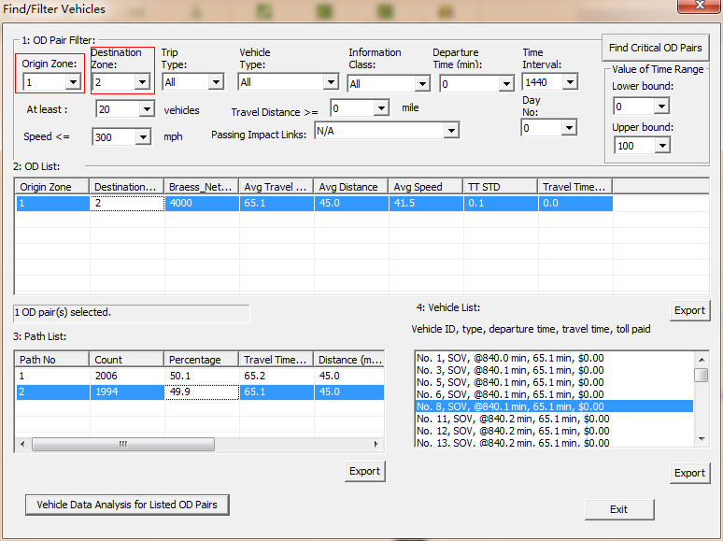

Select “1” under the tab “Origin Zone” and “2” under “Destination Zone”, which displays an OD pair from Zone 1 to Zone 2 under OD list. The Braess_Network Count, Average Travel Time, Average Distance, Average Speed, TT STD and Travel Time per Mile STD are shown in the OD list. Click on the OD list populated, and then we can see the path list related to the demand, travel time at paths 1 and 2.

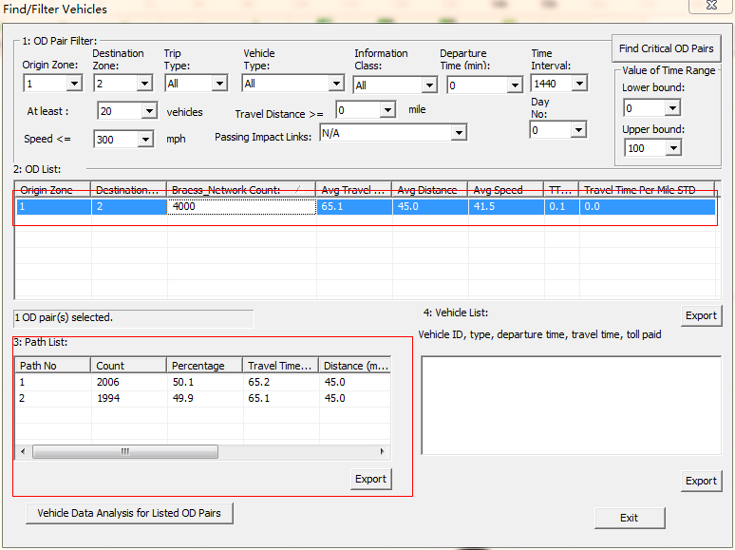

Choose one of the paths by clicking on one row in the “Path List”, and the count of the vehicles taking the selected path are shown in “Vehicle List”. At the same time, the corresponding path is also highlighted in the map.

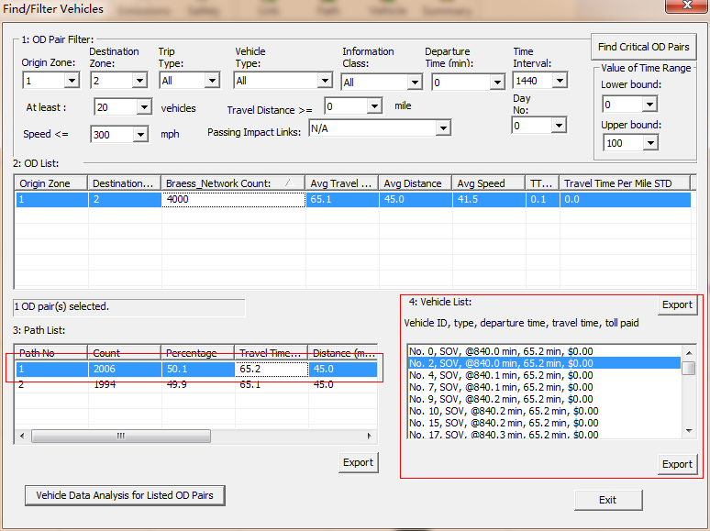

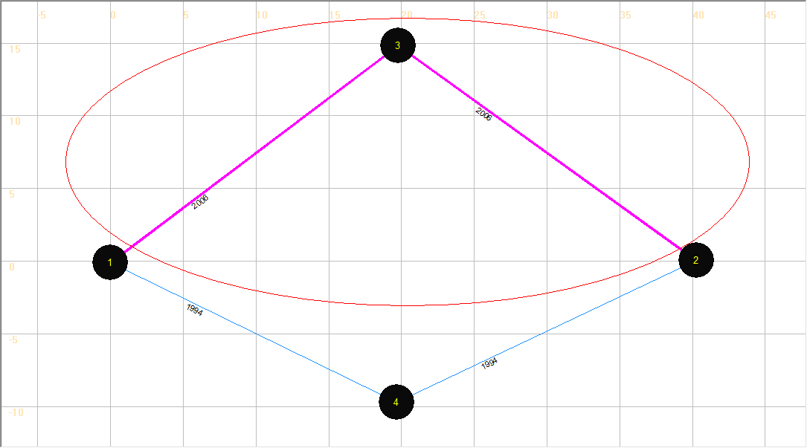

|  |
| --- |
| Remark  Under user equilibrium, travel time on both routes (with positive flow) should be the same. In this toy network, the number of vehicles on both routes should be the same.  As DTALite uses an agent-based assignment procedure (as opposed to the flow/fluid based representation) and the Method of Successive Averages is selected, at iteration 20, a small number of agents (5% of 4000 vehicles = 200 vehicles) are selected randomly to switch to the shortest path route. The numerical rounding error can lead to 2006 vehicles on route 1, 1994 vehicles on route 2, as opposed to the theoretical value of 2000 vs. 2000 vehicles. |

Step 6: Use the “summary” button to verify the overall network performance.

Click the button  in tool bar, then a dialog box named “Data Summary Dialog” appears. Select items in X Axis and Y Axis Drop-down lists (For example, select “15-min Departure Time Interval” and “Cumulative Number of Vehicles”, respectively).

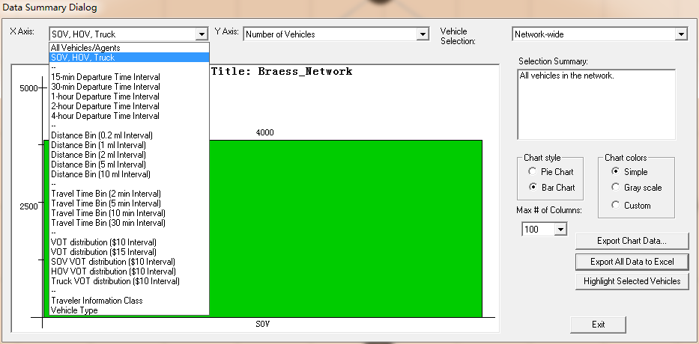

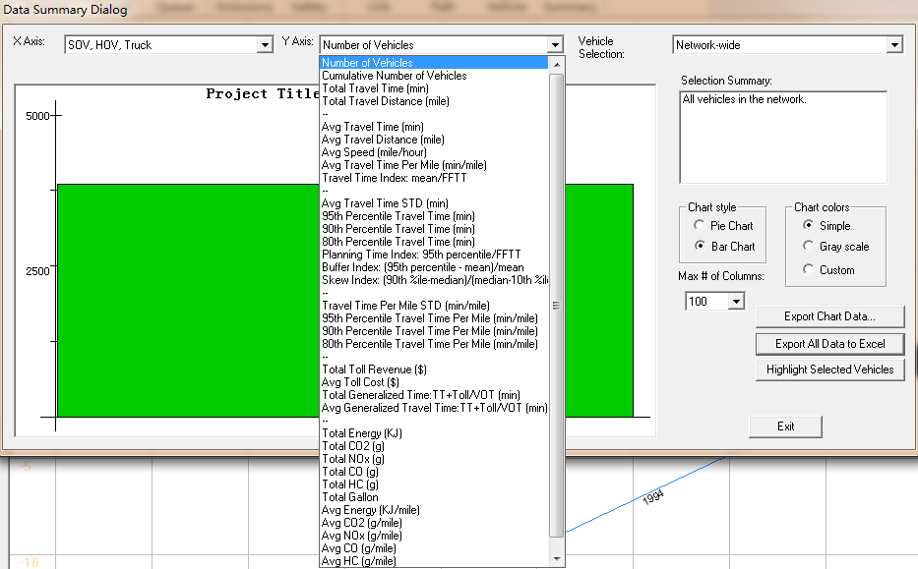

The figure plots the Cumulative Number of Vehicles is shown below as an example.

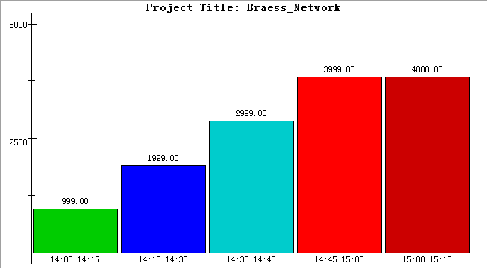

Select the item “Avg Travel Time (min)” under the Y Axis drop-down list to show the average travel time in the network.

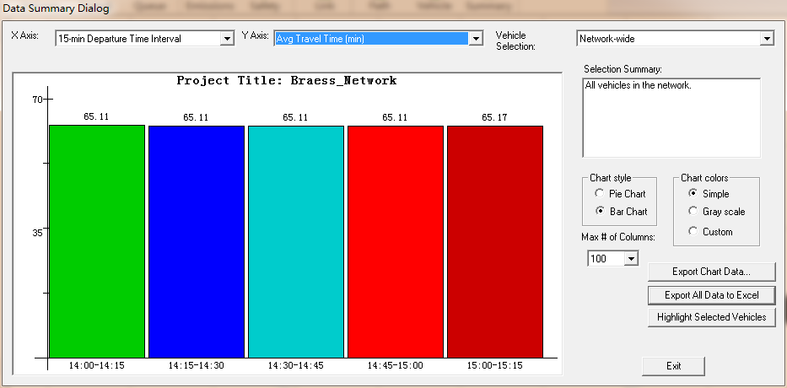

Try to change items in the drop-down lists and figure format (pie chart vs. Bar Chart) to check other network performances.

Step 7: Close NEXTA.

# Task 3: Add a link 3->4 into the Braess network and run the static simulation.

Note: There are two ways to add a new link 3->4. You can add the link directly on the map, and change the link attributes by clicking on the link layer, right click the View Link Properties for Selected Link meu to ensure FFTT on link 3->4 = 0.

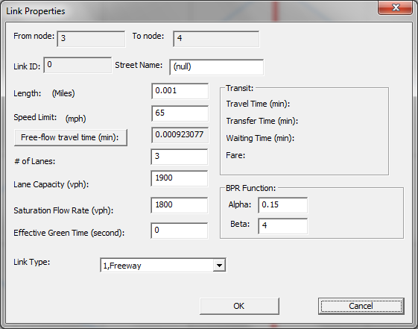

The second way to add this link is to change the Excel file to be described below.

Step 1: Open the Excel file “Braess_Network.xls” and add basic information of link 3->4 (e) into the “3-link” sheet, save the Excel file as “Braess_Network_with_link3_4.xls”. Close the Excel file.

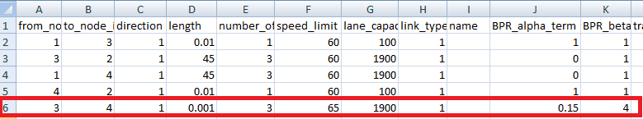

Step 2: Now, import the changed Excel file “Braess_Network_with_link3_4.xls” into NEXTA to create a new network, and then save it as “Braess_Network_with_link3_4.tnp”.

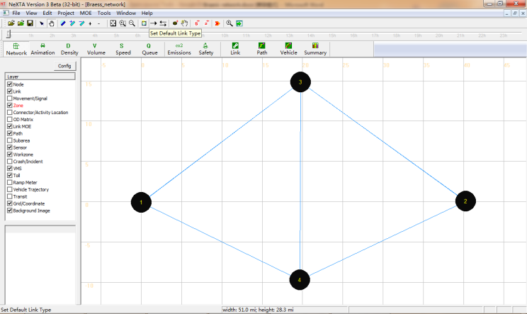

Step 3: Run the simulation for the new network by choosing “BPR Function” under the Traffic Flow Model list and “Method of Successive Average” under the “Traffic Assignment Method” list.

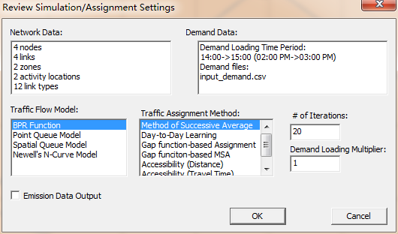

Step 4: Display the volume values on each link in the new network (Using Config).

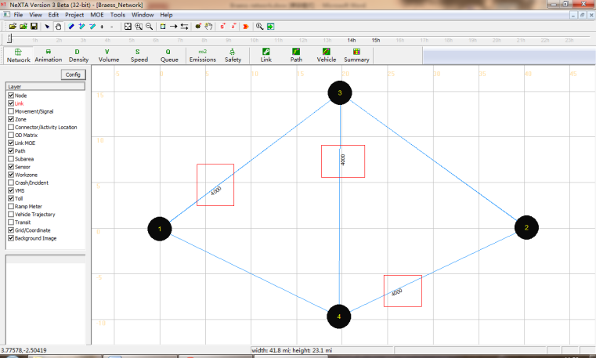

The volumes on each link are shown in the table below.

|  |  |  |  |  |  |
| --- | --- | --- | --- | --- | --- |
|  | a | b | c | d | e |
| Total Link Volume(vhc) | 4000 | 4000 | 0 | 0 | 4000 |

Table: Showing the simulation result

Step 5: Vehicle path dialog.

There are 3 paths from Node 1 to Node 2 in Braess network (shown in different colors). For convenience, we mark them as path 1, path 2 and path 3 in the figure shown below.

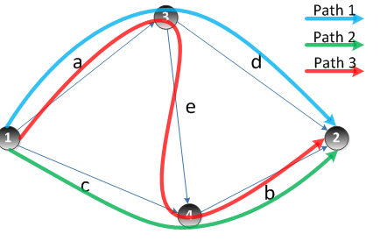

# Task 4: Using NEXTA to display the shortest path in Braess network.

Click “Path” on the GIS Layer Panel Menu on the left side of your screen. Right click on Node 1 to choose the option “Direction from here”. Node 1 becomes a red highlighted box, ‘A’, indicating the start point of the shortest path. Then right click on Node 2 to choose the option “Direction to here” and it becomes a red highlighted box, ‘B’.

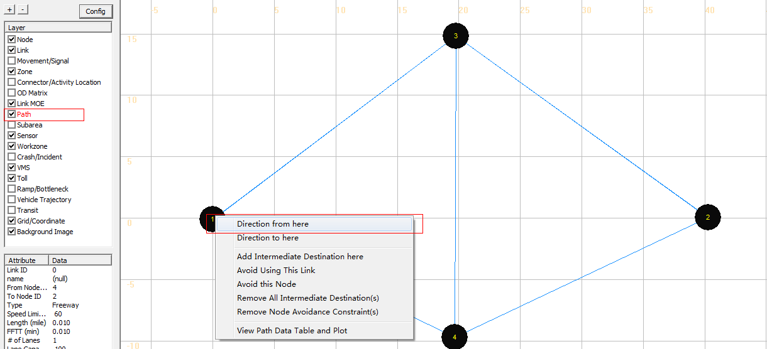

The shortest path from Node 1 to Node 2 is highlighted in the map as shown below. To unselect A and B, you can uncheck the path layer.

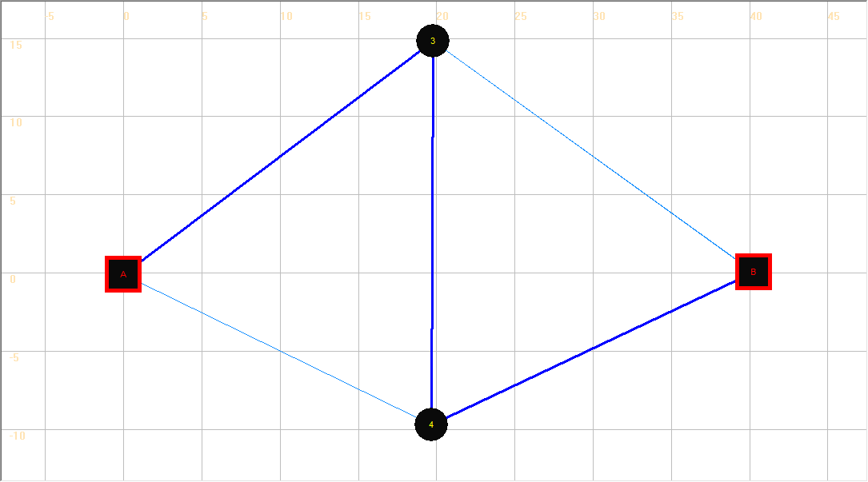

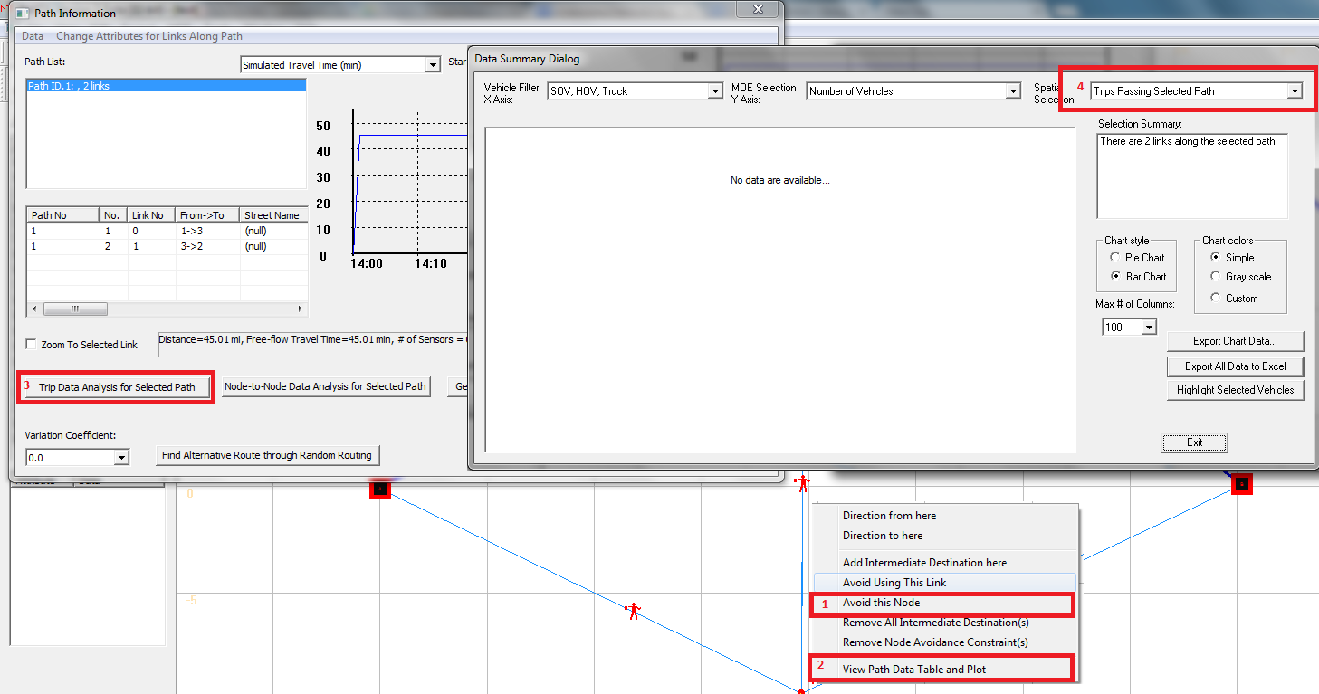

To perform selected path analysis along the path A->3->B, please go to the path layer, right click on node 4, click on the “avoid this node” menu, which will block two related incoming links. Then right click on node 4, click on the View Path Data Table and Plot menu to active the Path Information Dialog, and then click on the Trip Data Analysis for Selected Path button to active the Data Summary Dialog. The spatial selection should be Trips Passing Selected Path. As no vehicles use this route, no data is available for this selection.

|  |  |  |
| --- | --- | --- |
|  | Travel time | Flow |
| Path 1 | Link a(40.01) + Link d(45) = 85.01 min | 0 |
| Path 2 | Link c(45) + Link b(40.01) = 85.01 min | 0 |
| Path 3 | Link a(40.01)+ Link e(0.001)+ Link b(40.01) = 80.02 min | 4000 |

Step 5: Close the NEXTA.

# Task 5: Compare System-wide Performance Differences between Two Networks.

The Braess paradox is a User Equilibrium (UE) system that is not necessarily System Optimal (SO). Under the UE principle, the users are assumed to be greedy and rational to choose their own route with minimum cost, and users are familiar with the system. The UE conditions are described as follows:

No individual trip maker can reduce his path costs by switching routes. All used routes between an O-D pair have equal and minimum costs, while all unused routes have greater or equal costs (to the used path costs).

From the displayed values of the volume on two different networks mentioned above, we can complete the following table.

|  |  |  |
| --- | --- | --- |
|  | Without adding link e | Adding link e |
| Total number of vehicles | 4000 | 4000 |
| System-wide total travel time | 260040.7 | 320083.8 |
| Average travel time for each vehicles | 65.01 | 80.02 |
| Volume on link a | 2006 | 4000 |
| Volume on link c | 1994 | 0 |
| Path 1 travel time | 65.07 | 85.01 |
| Path 1 volume | 2006 | 0 |
| Path 2 travel time | 64.95 | 85.01 |
| Path 2 Volume | 1994 | 0 |
| Path 3 travel time | —— | 80.02 |
| Path 3 Volume | 0 | 4000 |

|  |
| --- |
| Remarks:  Comparing the average travel times before and after the addition of link e, it is interesting that the average travel time increases from 65.01-min to 80.02-min, due to the addition of link e. After adding link e into the Braess Network, all the vehicles travel through link e, and the system-wide total travel time increases significantly. However, for one single vehicle, the driver does not have an incentive to switch his route, as the travel times for the other two paths (Path 1 and Path 2) are 85.01 minutes when all the other vehicles travel through link e (except for that one vehicle). Therefore, there is a paradox on Braess network under reasonable assumptions, necessary and sufficient conditions in a general transportation network. |

It should be noted that the length of link e must be short enough to ensure that the travel time on path 3 is less than the travel times on both path 1 and 2.

# Task 6: Add a Link Toll and Run Static Simulation

Step 1: Click  on Tool bar to open “Braess_Network.tnp” file. We can see that the Braess network with link e is displayed on the map.

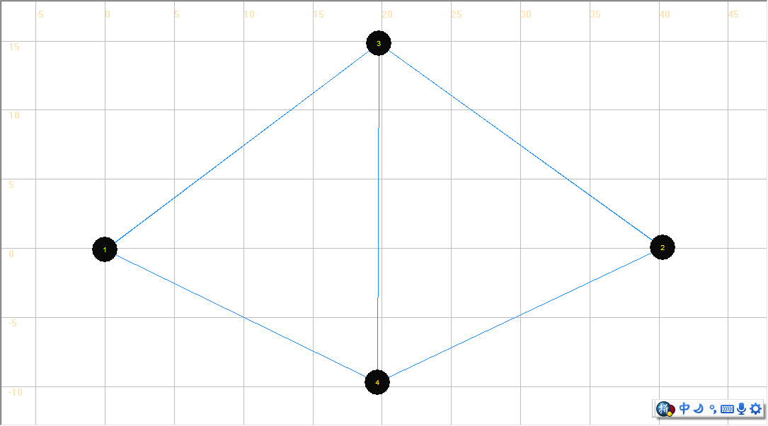

Step 2: Click “Toll” on the GIS Layer Panel, and then click  to select link e. Set link e as a Toll link by clicking “Add Link-based Toll” in the right click drop-down list.

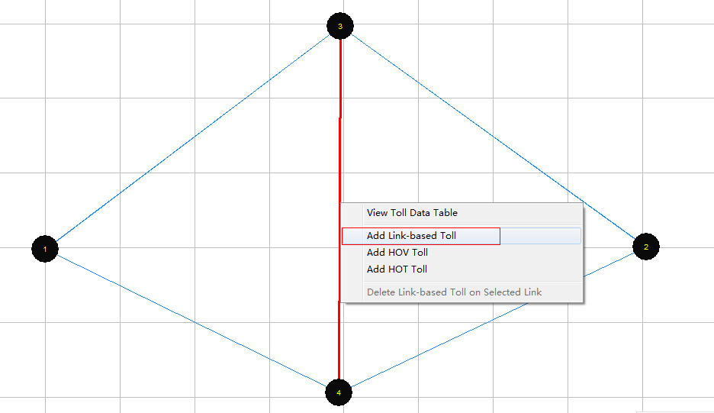

A dialog box named “View/Edit Scenario Configuration” appears. The users can modify the values of the charge of toll on the link. After inputting the desired charge of toll, click “Save Data”.

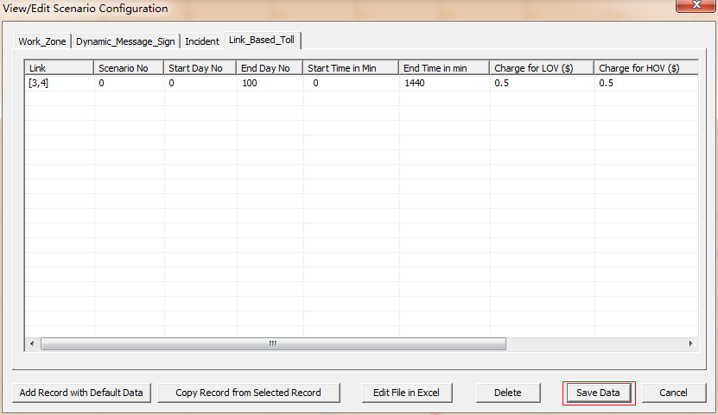

Step 3: Run simulation on the new network and display the volumes on the map.

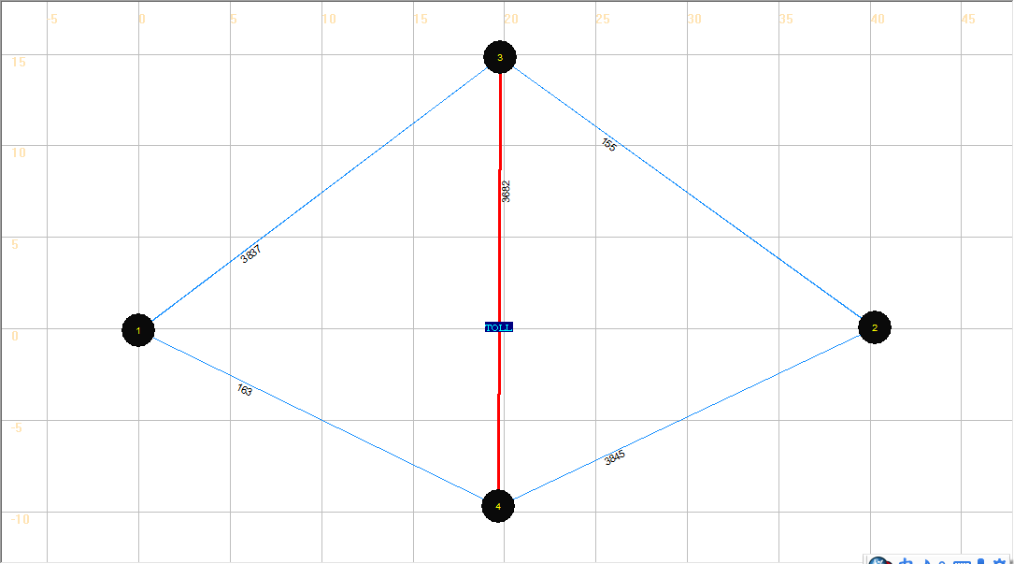

|  |  |  |  |  |  |
| --- | --- | --- | --- | --- | --- |
|  | a | b | c | d | e |
| Total Link Volume(vhc) | 3837 | 3845 | 163 | 155 | 3682 |

We can see some vehicles shifting from Path 3 to Path 1 and Path 2 because of introducing the toll on path 3.

Step 4: Close NEXTA.

# Problem 1: Sensitivity analysis using different demand levels

In this problem, we will explore the sensitivity of Braess paradox to different demand level. Try to change the demand in Braess network, and run static simulation to do sensitivity analysis.

1. Analysis of low demand on Braess Network

Step 1: Launch NEXTA, and open the file ” Problem1_Braess_Network.tnp” in the folder “Internal_release\test_data_sets\Baress Network Data Sets\Problem1-Braess_network_with_link34-static - low” by clicking  in Tool Bar. Braess network appears on the interface.

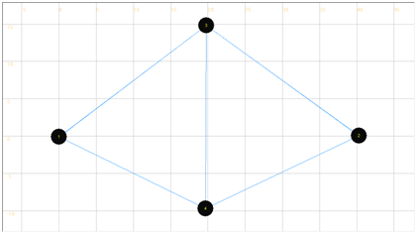

Step 2: Click the button  to modify the demand to low level.

In the dialog “Review Simulation/Assignment Setting”, we can change the value of “Demand Loading Multiplier” at 0.1. Then, the demand will change into 4000*0.1=400 (the original demand is 4000 ).

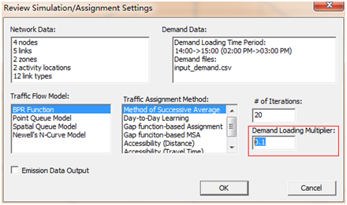

Step 3: Run simulation using “BPR Function” as “Traffic Flow Model” and “Method of Successive Average” as “Traffic Assignment Method” on Braess network, display the volume value on the network.

|  |  |  |  |  |  |
| --- | --- | --- | --- | --- | --- |
|  | a | b | c | d | e |
| Total Link Volume(vhc) | 400 | 400 | 0 | 0 | 400 |

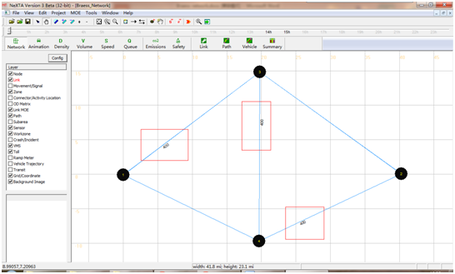

Step 4: Check the values of parameters from the output files,

Step 5: Delete Link e from Excel File.

Step 6: Import the data set.

Step 7: Run the simulation

Keep the “Demand Loading Multiplier” at 0.1. Use BPR Function to run simulation and display the volume values on each link.

|  |  |  |  |  |
| --- | --- | --- | --- | --- |
|  | a | b | c | d |
| Total Link Volume(vhc) | 188 | 212 | 212 | 188 |

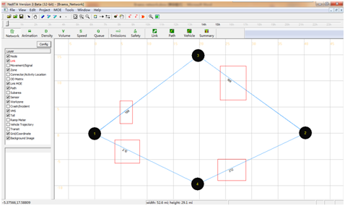

Step 8: Compare and analysis the system performance between two networks under low demand.

|  |  |  |
| --- | --- | --- |
|  | Without adding link e | Adding link e |
| System-wide travel time | 18806.88 | 3208.37 |
| Volume on link a | 188 | 400 |
| Volume on link c | 212 | 0 |
| Path 1 travel time | 46.89 | 49.01 |
| Path 1 volume | 188 | 0 |
| Path 2 travel time | 47.13 | 49.01 |
| Path 2 volume | 212 | 0 |
| Path 3 travel time | —— | 8.02 |
| Path 3 volume | 0 | 400 |

From the statistics above, the system performance of the Braess network with link e is much better than the other’s. The travel time for a single vehicle or whole system decrease because of link e. Thus, no paradox occurs.

Step 8: Close NEXTA.

2. Analysis on high demand on Braess Network

Step 1: Launch NEXTA, and open the project file from folder: ”Internal_release\test_data_sets\Baress Network Data Sets\Problem1-Braess_network_with_link34-static - high”

Step 2: Click the button  to modify the demand to high level.

In the dialog “Review Simulation/Assignment Setting”, we can change the value of “Demand Loading Multiplier” at 2.5. Then, the demand will change into 4000*2.5=10000 (the original demand is 4000 ).

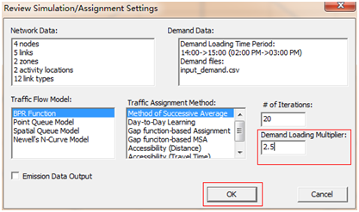

.

Step 3: Choose “BPR Function” in “Traffic Flow Model” list and “Method of Successive Average” in “Traffic Assignment Method” list on Braess network, then click OK to start simulation. Display the volume values on the map.

|  |  |  |  |  |  |
| --- | --- | --- | --- | --- | --- |
|  | a | b | c | d | e |
| Total Link Volume(vhc) | 5463 | 5020 | 4537 | 4980 | 483 |

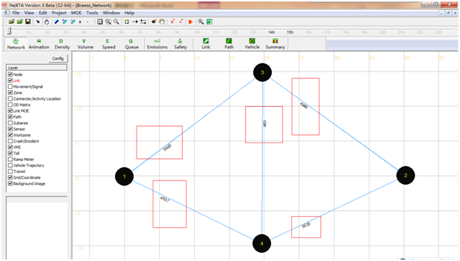

Step 4: Record the values of parameters from the output files, then close NEXTA.

Step 5: Delete link e from the Excel file you imported.

Step 6: import the data, and save the network.

Step 7: Keep “Demand Loading Multiplier” at 2.5. Run the simulation using BPR Function to obtain the volume values on each link.

|  |  |  |  |  |
| --- | --- | --- | --- | --- |
|  | a | b | c | d |
| Total Link Volume(vhc) | 4827 | 5173 | 5173 | 4827 |

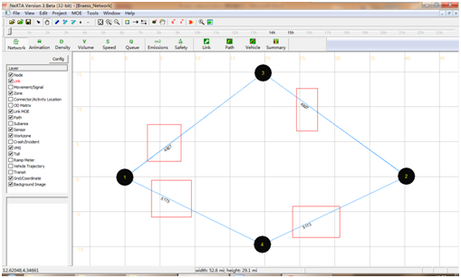

Step 7: Compare and analysis the system performance between two networks under low demand.

|  |  |  |
| --- | --- | --- |
|  | Without adding link e | Adding link e |
| System-wide travel time | 950698.6 | 978817.97 |
| Volume on link a | 4827 | 5463 |
| Volume on link c | 5173 | 4537 |
| Path 1 travel time | 93.28 | 99.64 |
| Path 1 volume | 4827 | 4980 |
| Path 2 travel time | 96.74 | 95.21 |
| Path 2 volume | 5173 | 4537 |
| Path 3 travel time | —— | 104.85 |
| Path 3 volume | 0 | 483 |

From the statistics above, not all vehicles take the path 3 because of link capacity limitation. And the travel time on path 3 is a little longer than other two paths’. Neither does paradox occur under high demand in Braess network.

Step 8: Close NEXTA.